**DAILY ONLINE ACTIVITIES SUMMARY**

|  |  |  |  |  |  |  |  |  |
| --- | --- | --- | --- | --- | --- | --- | --- | --- |
| **Date:** | **03/07/2020** | | | | | **Name:** | **POOJA D S** | |
| **Sem & Sec** | **IV Sem & B section** | | | | | **USN:** | **4AL18CS056** | |
| **Online Test Summary** | | | | | | | | |
| **Subject** | | **-** | | | | | | |
| **Max. Marks** | | **30** | | **Score** | | | **-** | |
| **Certification Course Summary** | | | | | | | | |
| **Course** | **Introduction to Programming** | | | | | | | |
| **Certificate Provider** | | | **Great learning academy** | | **Duration** | | | **5.5hours** |
| **Coding Challenges** | | | | | | | | |
| **Problem Statement: -------------** | | | | | | | | |
| **Status: ------------** | | | | | | | | |
| **Uploaded the report in Github** | | | | | **YES** | | | |
| **If yes Repository name** | | | | | <https://github.com/dspooja/C-coding> | | | |
| **Uploaded the report in slack** | | | | | **YES** | | | |

Online Test Summary: No internals conducted today.

Online Certification Course Summary: In today’s session I have about the Intro to Inheritance, joining NumPy Arrays, Numpy Intersection & Different, etc.

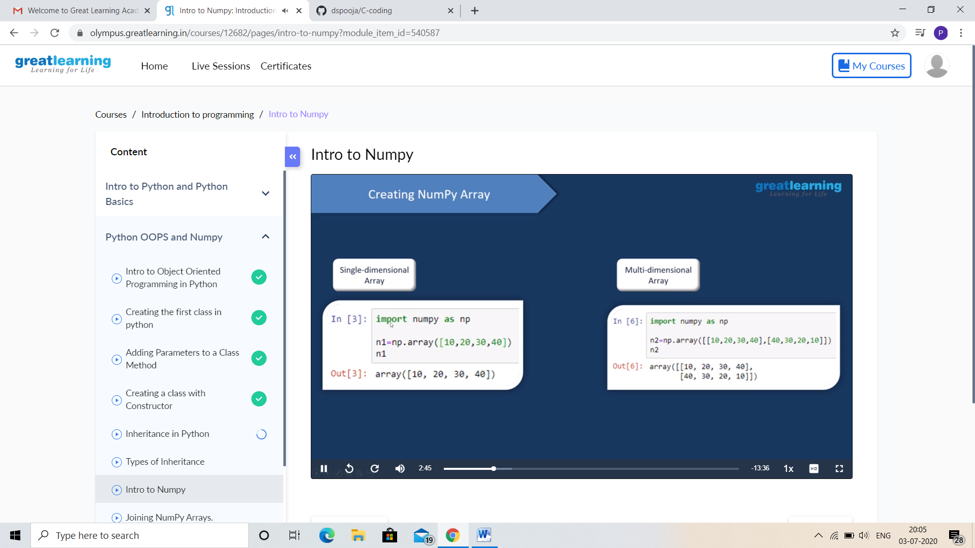

This is the snapshot of today’s session.

And I participated in the webinar “FACE RECOGNITION USING DEEP LEARNIING” on 30th June.

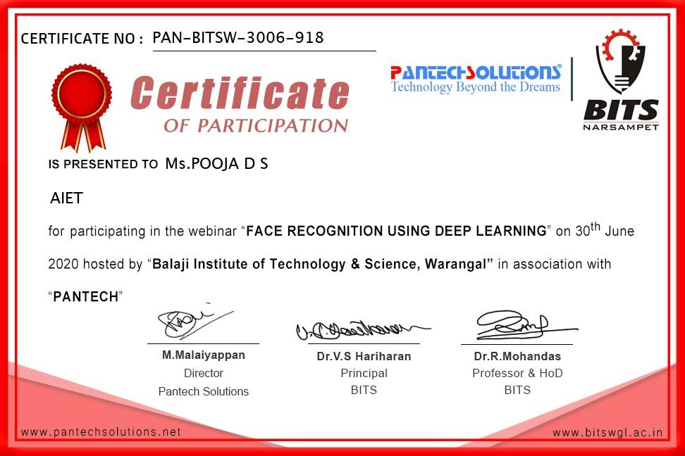

Online Coding Summary: **No received programs today.**

Online Training: Today I had attended the online training organized by CSE Department AIET. The training was on C programming language topics are Structures and Unions, Memory Management done by Prof. Megha D. CSE Dept. After the session the quiz was conducted.